www.adk-nfc.org | November 2020

Newsletter of the Adirondack Mountain Club – Niagara Frontier Chapter

Presentation:
Our Virtual
General Meeting…

Tuesday, November 10, at 7 PM

You will receive the invitation to the Zoom meeting in a separate email closer to that date.
Saving Old Growth Trees
at College Lodge Forest near Fredonia

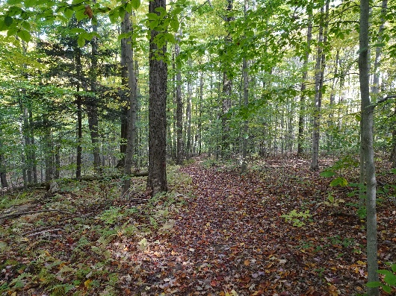
Learn how the WNY Land Conservancy is working to preserve 168 acres of old growth forest, wetlands and trails located at the College Lodge Forest in Chautauqua County. During the Great Depression, the Fredonia Faculty Student Association (FSA) purchased land that became a place to recreate and to be used as a natural laboratory. Due to financial concerns, the FSA is keeping the area that contains the buildings and is looking for a buyer for the surrounding forest. The forest is in danger of being logged if the Land Conservancy cannot raise the funds to purchase the property. This special place is known for its wonderful bio-diversity and contains hundreds of species of plants and animals and provides a safe resting area for migrating birds.

Kyle Semmel, the WNY Land Conservancy Communication Manager, will enlighten us about the Land Conservancy’s mission and the natural wonders of the College Lodge Forest. Kyle has previously worked in a variety of capacities at several nonprofit organizations. He is a writer, a literary translator for Danish and Norwegian books and is currently the Executive Director of Writers & Books in Rochester, NY.

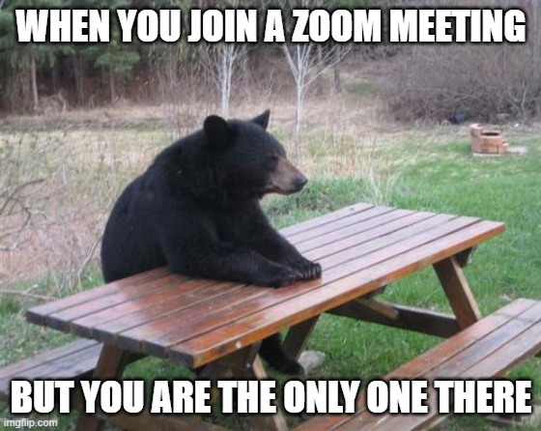
Looking Ahead …

In place of our traditional December potluck, we will be doing a zoom slide show to show off your photographic talents. Dig through your archives and pick out your 10 best nature pictures that hold special memories of past ADK outings, wildlife or breathtaking vacations. Please email 10 or fewer photographs to our slide show organizer Doug Gaffney dgaffney@roadrunner.com by Sunday December 6th, 2020
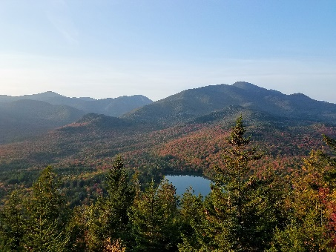
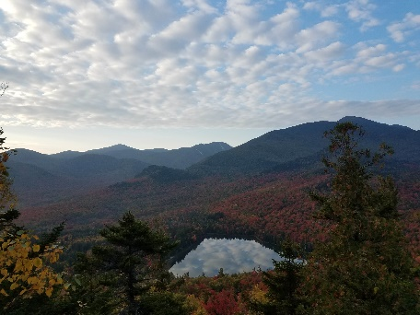
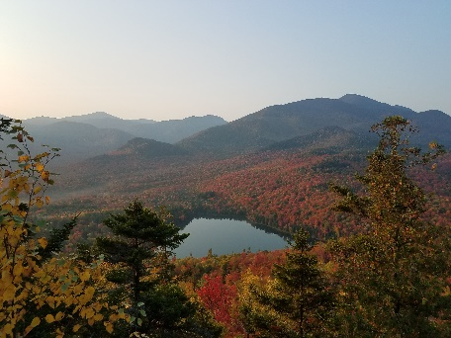
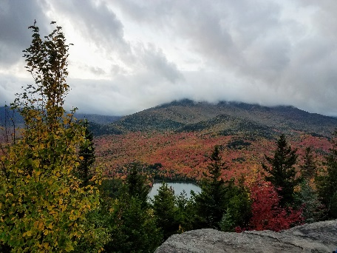
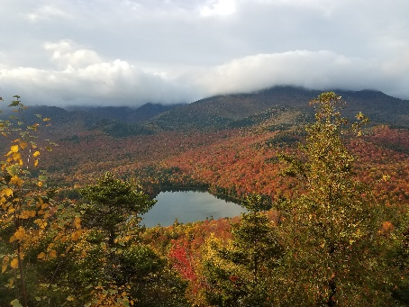
October 1st-5th Foliage Progress from Mt. Jo

IMPORTANT ANNOUNCEMENT REGARDING OUR NEWSLETTER

At our October meeting, the executive committee made the difficult decision to permanently discontinue distributing printed and mailed copies of our chapter newsletter. Over the past several years, fewer and fewer members have opted to receive a paper copy. Now, only a tiny fraction of our membership continues to do so.

In making this change, our chapter joins an increasing number of organizations which have decided to rely on electronic means to distribute information which has a short lifespan, and is constantly being updated. This change will also help reduce our carbon footprint, as well as to conserve vital resources.
Message from the Chair

One thing we can be thankful for in these difficult times is that we have had a beautiful late summer and fall. Our outings program has resumed, and so far, it has been successful. I hope everyone has had a chance to get out and enjoy themselves and this fine weather.

Last month, I made an appeal to our members to consider volunteering for one of the open leadership positions in our chapter. So far, I have not received any replies. So, I repeat my appeal. For our chapter to survive and thrive, we need your help.

At the October executive committee meeting, we decided to offer a Zoom chapter meeting every month, as long as a program can be arranged. Stay tuned for further announcements in the weekly updates.

Take care, be safe, and stay healthy…
— Paul M. Gannon

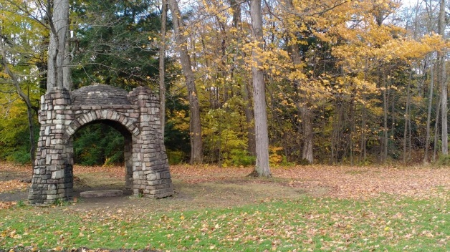
Outings

11/01 - SUN - HIKE - Chestnut Ridge Park (B)
Early morning start. Meet in the Corral parking lot. We will hike the 5.5 mile red and blue trails at a moderate pace. Please bring hiking poles, the 10-essentials, snack, and sufficient water. Hiking boots and poles are recommended.
Call Leslie at 716-560-1311 or email lesliesalathe@live.com for Covid protocols and time of hike.

Conservation Corner

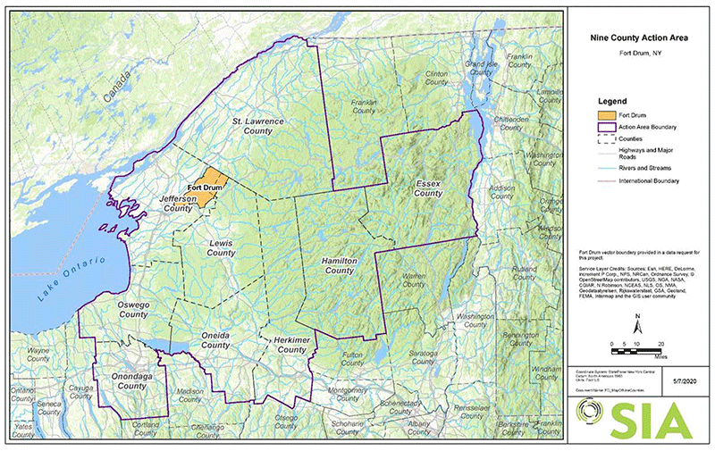
Join the first ever ADK-NFC Conservation Committee Zoom Meeting

November 17, 2020 at 7pm - Committee members will be emailed a link to join the zoom meeting on their electronic device or for those who prefer they can participate via the phone. Everyone is welcome to join the discussion about local and statewide conservation issues. Contact Lynn Kenney, (716) 825-7329 or woodthrush3@hotmail.com for the link.

Military Operations in the Adirondack Park

A programmatic environmental assessment (PEA) from the 10th Mountain Division of the U.S. Army, based at Fort Drum proposes the possible use of land in nine New York counties – two of which completely within the ADK Blue Line. Needing clear space of 5 to 10 acres for “…training sessions would combine air and on-ground motor vehicle activities and run for 14 days, with a 7-day clean-up period to “return the property to its condition prior to the exercise,” hence totaling 21 days each.” These training periods would commence six times a year …
This map details the nine county area where the 10th Mountain Division is seeking to stage combined air and ground training operations outside of the base in remote settings that would last 21 days each.
Source: Protect the Adirondacks

“The basic Wilderness definition states that lands classified as Wilderness should be managed in a wild, natural, untrammeled state where any impacts or marks of humans are difficult to detect. Protect the Adirondacks finds that the scope of activities in the PEA are incompatible with Wilderness lands in the Adirondack Park.”

“While motorized activities are authorized in Wild Forest areas, clearings of 5 to 10 acres do not exist. The PEA states that it’s proposed field training activities require clearings of 5 to 10 acres and these would not be possible even in Wild Forest areas where some kinds of motor vehicle use is allowed.”

Larry Beahan, Secretary | ADK-NFC notes, “Actively logged conservation areas are available and should be used for this purpose.” While Kate Hacker, Director | ADK-NFC assures us that, “The main club is joining efforts to work against this.”

Full article by Protect the Adirondacks may be viewed here: https://www.protectadks.org/problems-with-10th-mountain-division-training-proposal-in-adirondacks/

Sustainable Trail Design, Not Hiker Permits

A peer reviewed essay from members of ADK-GVC bring to light that the riverbed muddy, challenging, difficult, yet endearing trails we’ve come to know and love in the Adirondack Mountains were never entirely ‘designed’. They were the most direct route – not only were these trails created decades ago, but also could never have imagined sustaining such use!
Khang and Chris of Rochester, NY have outlined great reasoning that the DEC could very well consider – from enlisting professional trail crews dedicated to building sustainable trails to revenue options beyond hiking permits. Most notably, their essay has gained a lot of traction over the passing weeks.

Full essay may be viewed here: https://www.sciencepolicyjournal.org/uploads/5/4/3/4/5434385/huynh_koudelka_jspg_v17.1.pdf
Trip Reports

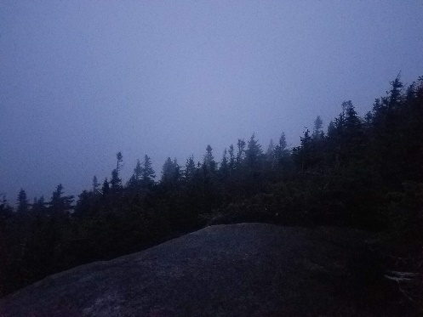
09/29/20 – HIKE – Saranac 6 Ultra
Daybreak atop McKenzie

Starting out at 3:45 am, a couple of hikers set off down the Jack Rabbit Trail to a heard-path (which proved difficult to follow in the dark) leading up the backside of Haystack Mtn; at 4:45 am, its summit revealing a starry sky with a breeze bringing in quick moving clouds.
Over to McKenzie, an ever widening trail, washouts, and landslides also proved difficult to follow in the dark. Many will be discouraged by multiple false summits, while we found walking along through the alpine zone magical. Reaching the (newly installed) summit signage at 6:30 am. With the clouds setting in, sunrise in the alpine was truly a golden hour.
The rain held off the majority of our hike up Scarface, meeting many fellow hikers trying to summit before the rain; reaching its elusive summit at 10:30 am. Half way through, we mentally prepared ourselves for the second half.
An unrelenting rainstorm made for a grueling climb to Ampersand; hikers on their way down saying, “It’s gonna be an all-day rain ya know.” But we were more than half way through! A deserted and viewless summit at 2:20 pm.
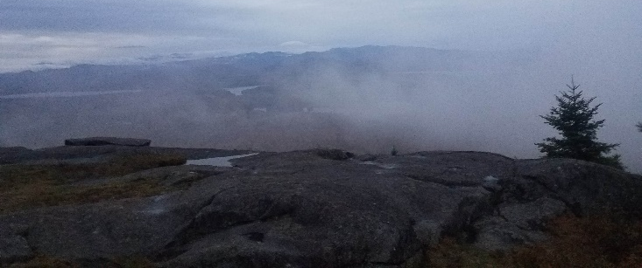
Completely soaked through, we changed into dry clothes and socks before driving to Paul Smith’s – the rain was letting up, but St. Regis tested our resolve - hiking two miles into the St. Regis Wilderness before even reaching the mountain. And, chasing daylight, we found the penultimate summit at 6:45 pm. With fading energy, I had half a PB&J before hiking out in the dark surrounded by eyes illuminated by my headlamp.
Baker Mtn, at times being a widened trail, we thought would be difficult to follow. Thankfully, little reflective markers glowed like spirit guides in the beams of our headlamps. Our last summit was reached at 9:50 pm.
Intermittent views atop St. Regis
Start 3:25 am, End 10:45 pm, Total time 19 hours, 20 minutes

- Submitted by Mary Kay Noack

10/03/20 - Another Adopt-A-Highway Clean-up In the Bag

Thank you to Judy Catalano, Jay Wopperer and Lynn Kenney for picking up garbage along the roads that surround the Tillman State Wildlife Management Area in Clarence, NY.

10/10/20 - HIKE - College Lodge Forest, Chautauqua County
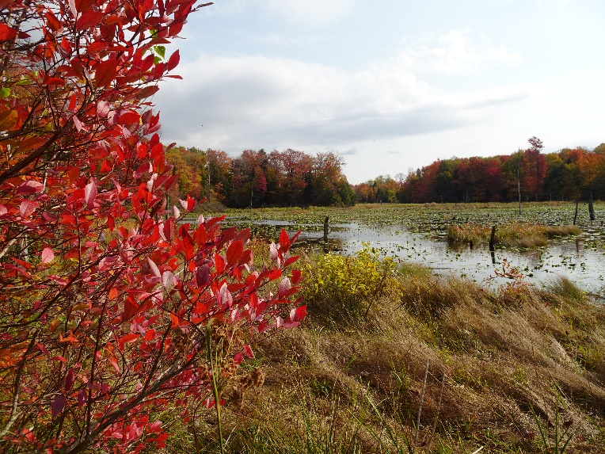
It was a beautiful day with fall colors at their peak as we trekked along the trails. The old growth hemlocks towered above us and the views of the ponds and wetlands made for an enjoyable hike. We explored an old stone foundation and mused how life must have been for that family. I am told the chapter used to run hiking and cross country ski outings to this spot but then it appears this area was “forgotten”. Now this gem is in danger of being sold and logged. Join the November 10th zoom meeting to find out how the WNY Land Conservancy is working to preserve this special place.

- Submitted by Lynn and Doug Kenney

Our Executive Committee
 | Chair | Paul Gannon | paulmgannon54@gmail.com | (716) 395-5739
 | Outings Chair | Greg Germaine | gwg99t@gmail.com | (716) 696-0829
 | Conservation Chair | Bob Van Hise | adkpaddles.bvh@gmail.com | (716) 628-0355
 | Programs Chair
 | Education Chair
 | Membership Chair | Kathy Clerkin | kmclerkin@gmail.com
 | Director | Kate Hacker
 | Alternate Director | Cheryl Peluso
 | Webmaster | Rob Laing | rlaing537@gmail.com
 | Treasurer | Doug Gaffney | dgaffney@roadrunner.com | (716) 631-3979
 | Electronic Communication Chair &  Newsletter Editor | Mary Kathryn Noack | marynoac@buffalo.edu
 | Secretary | Larry Beahan | larry_beahan@roadrunner.com | (716) 839-3112
 | Hospitality | Carol Schuster | carolfschuster@gmail.com
 | Archivist/Historian | Lynn Rehfeld-Kenney | woodthrush3@hotmail.com | (716) 825-7329
 | Outings Co-chair: Waterways | Richard Schraven | richardschraven1@gmail.com | (716) 564-2106
 | Outings Co-chair: Biking | Mike Lex | mblex@roadrunner.com | (716) 430-8986
 | Outings Co-chair: Hiking & Winter | Leslie Salathe | lesliesalathe@live.com

